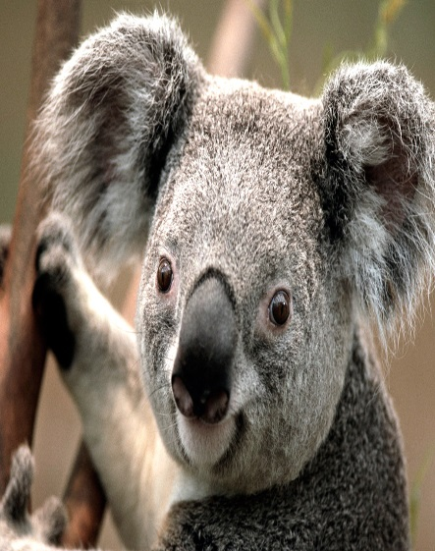 | FAZIL MADRASHA  MIRDI  SHOFIKUL ISLAM  PAKUNDIA.KISHORGONJ

